**EXP NO: 09 DATE: 14-03-24**

**Aim:** To Create a simple cloud software application for Hospital information system for SIMATS Hospital using any Cloud Service Provider to demonstrate SaaS with fields of patient name, age, address, phone, email, Attender name, attender phone, doctor name, diseases, etc.

**Implementation:**

1.Go to Zoho.com and login/signup

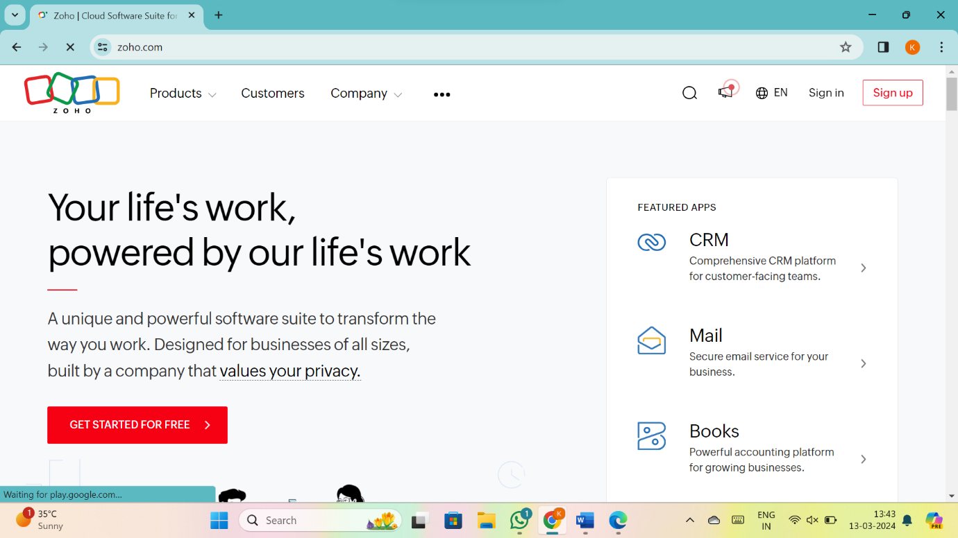

2.Go to Creator

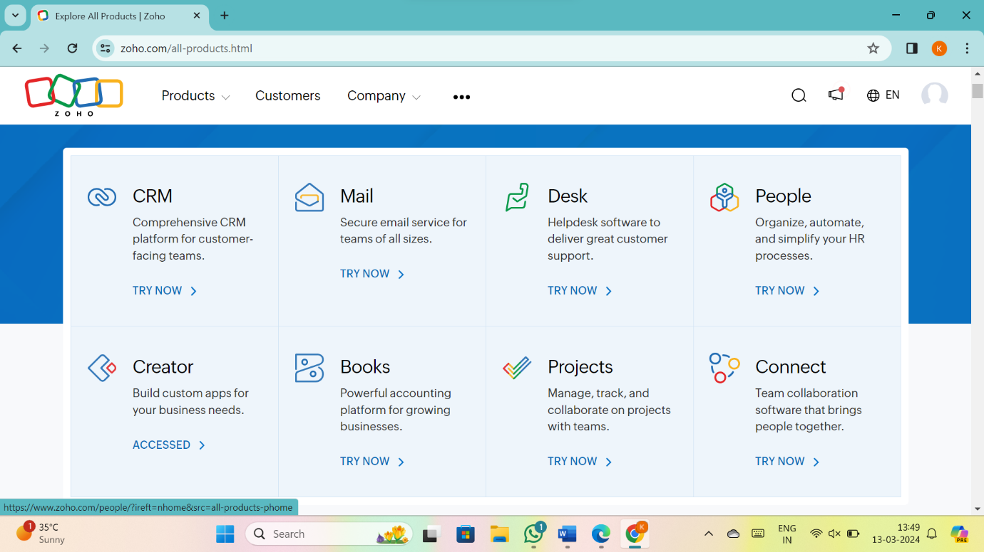

3. CREATE NEW APPLICATION

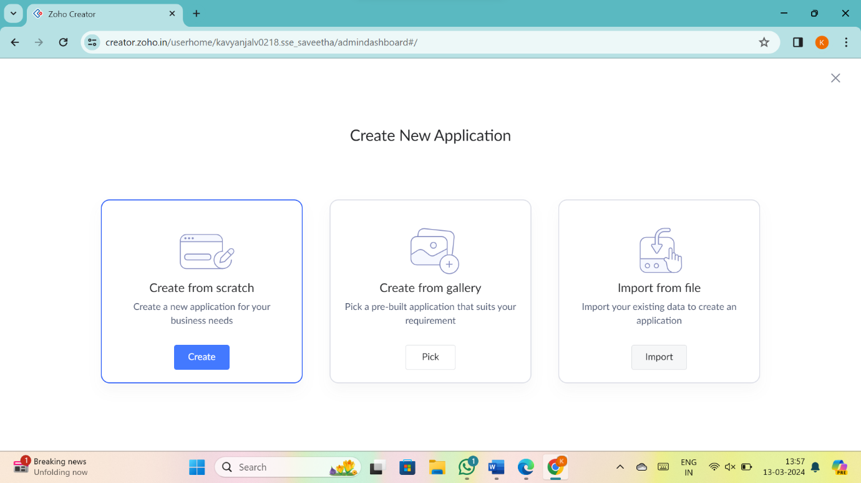

4.Give Application Name

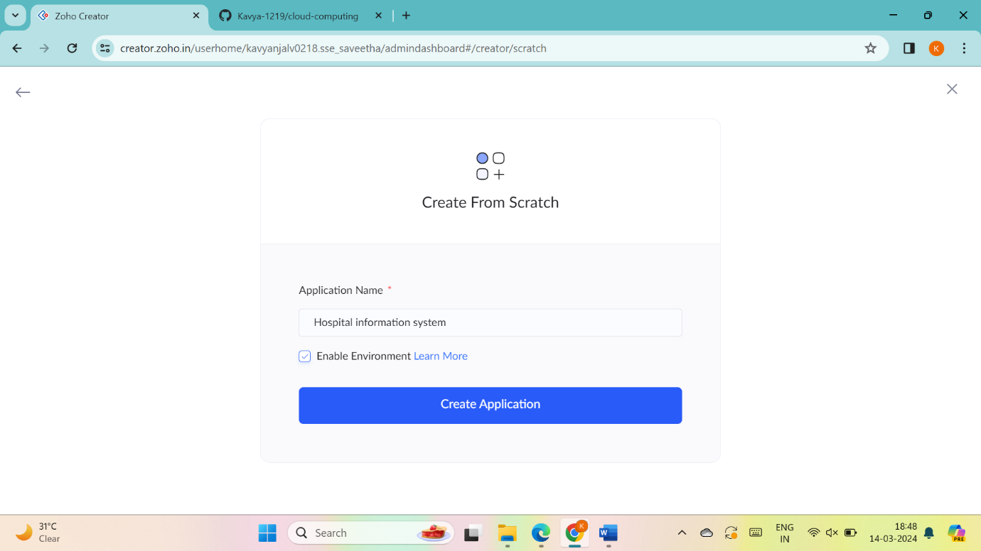

5.Create New Form

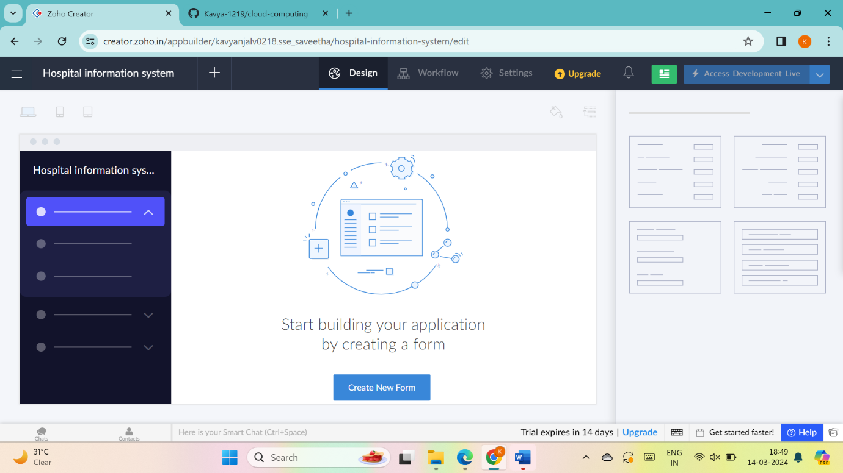

6.Select Form and give name

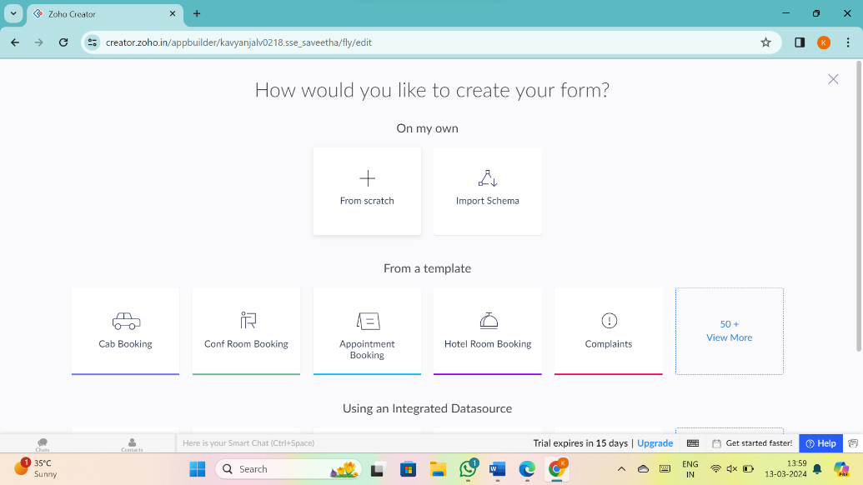

7.Drag necessary fields

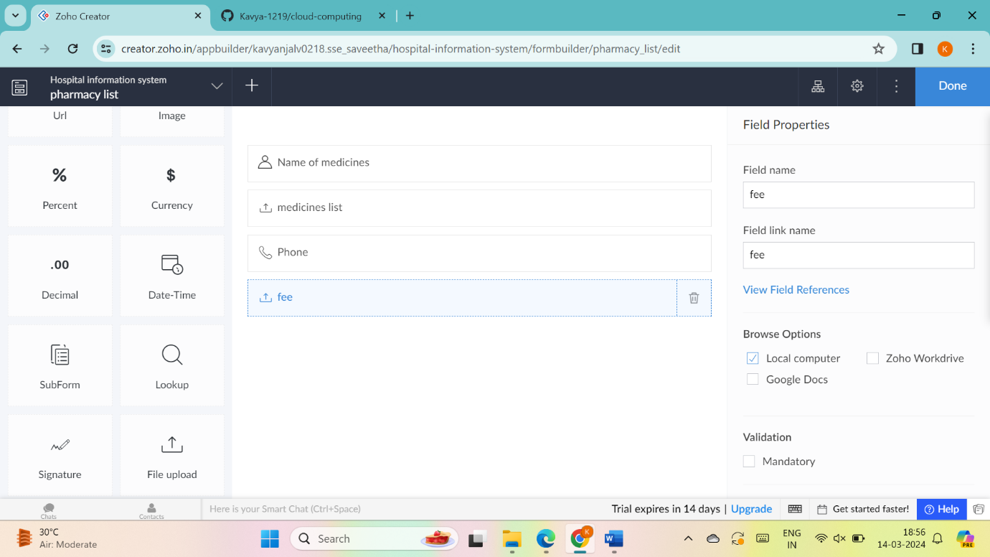

8.create new forms if necessary

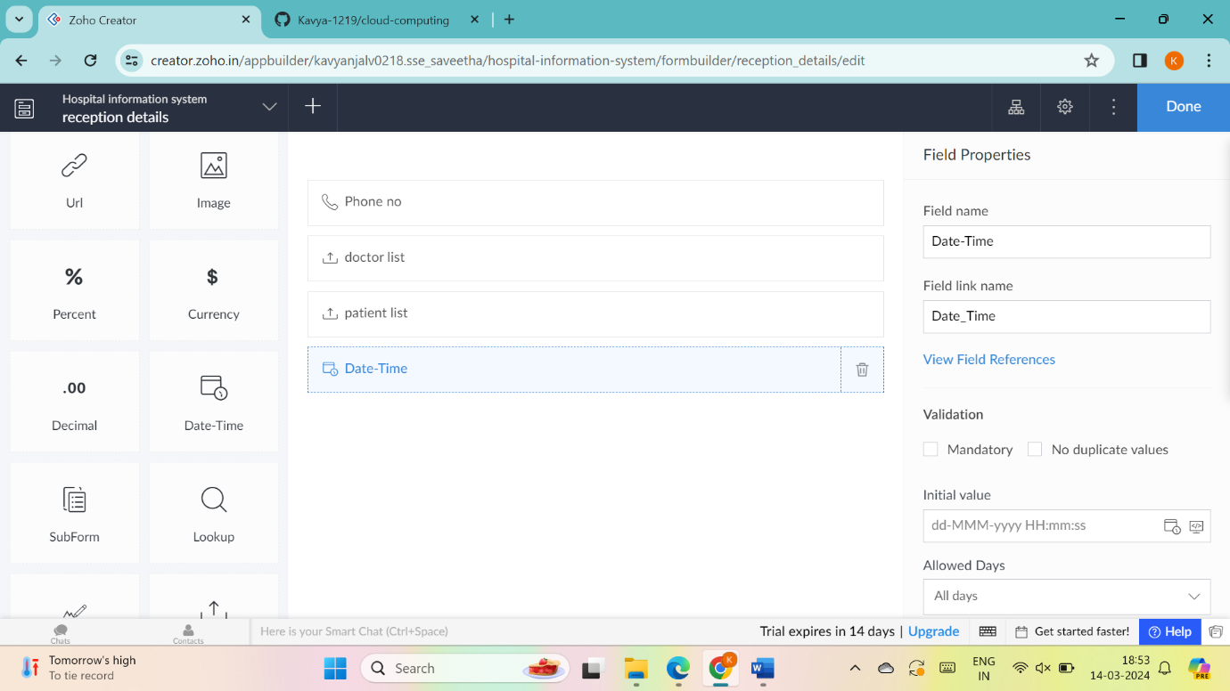

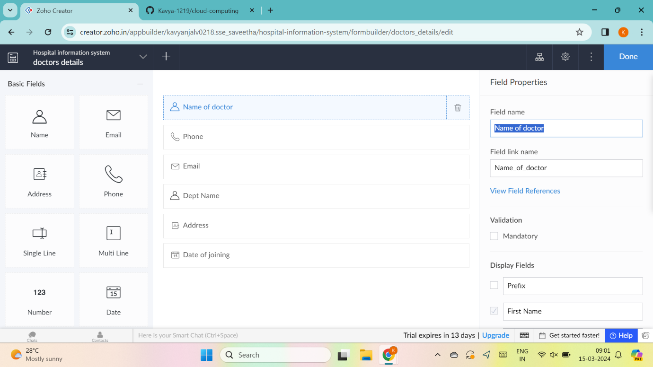

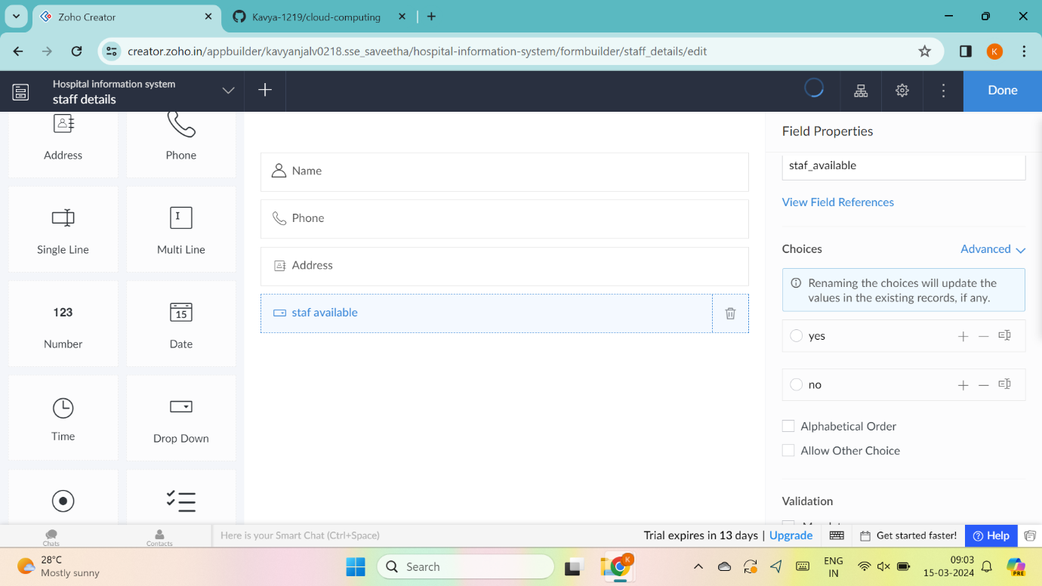

9.the software has been created

